

Course Syllabus Winter 2025

**Course Number: CSTP 2305**

**Course Title: iOS Mobile App Programming**

**Course Description:** In this course students study basic iOS application development for Apple mobile devices as well as cross platform application development for both Android and Apple devices. This course is designed for students who already have basic understanding of Object-Oriented programming using modern programming languages such as C++. Studies will learn how to use Apple's Swift programming language using development environment Xcode to develop general purpose application for Mac OS or iOS operating system. Students will utilize a cross platform development tool to create a mobile application that can run on multiple platforms. The emphasis in this course is gaining familiarity with the toolchain, the necessary APIs, working with MacOS and Xcode, and basic coding in the Swift programming language. Students will have access to modern Mac Labs to develop and test their applications, but for publishing and using the latest updates and packages it is recommended students have access to a Mac PC such as Mac mini.

**Class Meetings: Tue 9:00 – 12:30, Room 914**

**Instructor:** Xing Liu

**Email Address:** xliu@vcc.ca

**Instructor Availability:** Class time and online by appointment

**Course Length:** 15 weeks

**Teaching Hours:** 60 hours

**Credit Value:** 3 credits

**Course Competencies:**

Upon successful completion of this course, the student will be able to:

|  |
| --- |
| * Discuss application development for iOS mobile devices * Describe the development toolchain, testing, and publishing applications on Mac OS and iOS devices * Handle user touches, connect to the Internet, utilize accelerometer, timers and location in Mac or iOS environment * Develop software in Swift using Xcode that can run on an iOS devices and Mac PC. * Develop software that can run on an iOS device using object-oriented concepts * Employ basic debugging and troubleshooting on Mac PC * Develop a mobile application using a cross platform development tool that can run on multiple device platforms * Publish and submit an iOS application on the Apple App Store |

**Course Prerequisite:** CSTP 1105, CSTP 1206

**Instructional Strategies:** lectures, demonstrations, group discussions, computer lab and hands-on work

**Material and Supplies:** Material presented in class; Online resources.

**Estimated Homework Hours**: 4-8 hours per week

**Software Tools Needed:** Xcode on a MacBook computer **or** MacInCloud (sign up at *www.macincloud.com*)

**Required Textbook(s):**

SwiftUI by Example: can be purchased at https://www.hackingwithswift.com/store/swiftui-by-example

# Evaluation and Grading:

|  |  |
| --- | --- |
| Labs | 13% |
| Attendance  Quizzes | 7%  20% |
| Project | 25% |
| Midterm Exam | 15% |
| Final Exam | 20% |
| **Total Mark** | **100%** |

**Grading System:**

Letter Grade (A-F)

**Passing grade:**

C (61%)

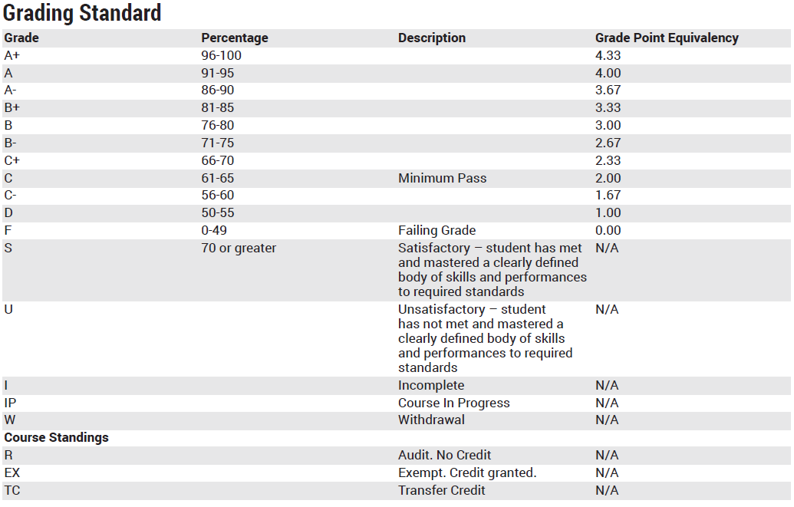

**Weekly Outline**

|  |  |  |  |  |  |
| --- | --- | --- | --- | --- | --- |
| **Week** | **Date** | **Topic** | **Assignments** | **Due Date** | **Marks** |
| Week 1 | Jan 7, 2023 | Introduction to XCode; Variables and Constants; |  |  |  |
| Week 2 | Jan 14, 2023 | Arrays, Dictionaries, Sets, and Enums | L1 |  | 5 |
| Week 3 | Jan 21, 2023 | Functions, Structures | L2 |  | 5 |
| Week 4 | Jan 28, 2023 | **Quiz 1**;Closures, Protocols, Optionals |  |  | **10** |
| Week 5 | Feb 4, 2023 | Text, Shape, Image | L3 |  | 5 |
| Week 6 | Feb 11, 2023 | View Layout, Stacks | L4 |  | 5 |
| Week 7 | Feb 18, 2023 | **Midterm Exam** |  |  | **15** |
| Week 8 | Feb 25, 2023 | State, TextField | **Project** **assigned** |  |  |
| Week 9 | Mar 4, 2023 | Events, More States, |  |  |  |
| Week 10 | Mar 11, 2023 | **Quiz 2**;Lists, Forms, |  |  | **10** |
| Week 11 | Mar 18, 2023 | Navigation, Menus |  |  |  |
| Week 12 | Mar 25, 2023 | Project examples |  |  |  |
| Week 13 | Apr 1, 2023 | Project examples |  |  |  |
| Week 14 | Apr 8, 2023 | **Project** submission |  |  | **25** |
| Week 15 | Apr 15, 2023 | **Final Exam** |  |  | **20** |

**POLICIES**

**Late Assignment Policy**

20% will be deducted for every 24 hours of lateness

# Attendance Policy

Vancouver Community College is committed to learning-centered, hands-on instruction, which can only be accomplished when students attend class. **There will be no excused absences.** The satisfactory explanation of an absence does not relieve the student from responsibility for the course work assigned and/or due during his/her absences. A student who does not attend class during the first week of school or starts late is still held responsible for his/her absences. Students who are marked absent from all scheduled classes for more than two consecutive weeks may be withdrawn from the College. Students should contact their academic advisor for appeal procedures following an attendance withdrawal.

Students are encouraged to make all schedule changes early in the first week of the quarter to minimize absences. Failure to sit in all classes during the first two weeks of school will result in termination from school for the quarter. Detailed information about scheduled adjustment periods can be found on the back of your official schedule or in the Academic Calendar.

# Student Responsibilities

This course is part of a demanding applied post-secondary education program and requires a significant commitment of time and effort. In addition to studying for examinations and preparing for class, students are required, on average, to dedicate between one to two hours to course-related work for every hour of instruction.

# Classroom Policies

* There is absolutely no use of cell phones and mobile devices during instructional time. Cell phones and mobile devices must be turned off as students enter a class. Web-surfing and game playing during instructional time are not allowed.
* Downloading and installing games onto school computers are not allowed. Do not unplug classroom computers from the network at any time as this may cause the network to become unreliable.
* If students wish to work in a classroom that is already in session, they must ask the instructor teaching the class for permission to enter. They may or may not be admitted – depending on the instructor’s discretion.
* Students are not to utilize lewd, indecent or obscene desktop screensavers in classrooms.
* Profanity, racial slurs, sexual comments, and vulgar language in class will not be tolerated. The instructor may remove students who do not behave in a professional and respectful manner. Students are required to actively contribute to their class environment in a positive fashion.
* Academic dishonesty is not tolerated at Vancouver Community College. Academic dishonesty or plagiarism is defined as any attempt to take the work of someone else and submit it, in part or in whole, as one’s own. Plagiarism includes the unattributed use of material from any source – including books, periodicals, streaming media, and the World Wide Web. All quotations, paraphrases or other adaptations of others’ work must be properly cited and documented. Any student who uses images, texts, or other media without proper attribution will be subject to the same penalties as students guilty of other types of academic dishonesty. For examples of academic dishonesty, please refer to the Academic Honesty Policy and Procedures in this syllabus.

# Food and Drink Policy

Vancouver Community College provides students, faculty and staff with cafeteria areas at each of its campuses. Food and drink should be enjoyed exclusively in these areas of the school. From time to time, food may be served at school events that take place in lecture rooms, art rooms or other public areas such as the atrium or the art galleries. These events are always sponsored and supervised by school officials.

# Students, faculty and staff are not allowed to bring food into classrooms at any time.

Drinks are allowed in lecture classrooms, drafting rooms and art rooms if they are in screw-top bottles or sealed-top travel mugs. Aluminum cans, open-top containers and other easily spilled vessels are not allowed. Due to the sensitive nature of the technology used in the computer labs, fashion labs and audio production studios, no food or drink is allowed in these rooms at any time. Shelves have been provided near the entrances of computer labs for students to store drink containers while in class. In consideration of other students, students should remove their drink containers from the shelves when they leave the classroom. As instructors often have to speak for long periods and may find it difficult to leave the classroom, instructors may bring a drink in an approved, sealed-top container into the classroom where they are teaching. Students are not allowed to bring food or drinks into computer labs, fashion labs or audio production studios. Students violating the food and drink policy may be asked to leave the classroom.

Breaks are provided at regular intervals in all classes so that students may leave the classroom to get refreshment. Drink containers should not be left outside of classrooms or in the hallways. Drink containers left outside of classrooms will be thrown out.

**Academic Honesty Policy and Procedures**

# Definition of Academic Dishonesty

Vancouver Community College defines an act of academic dishonesty as any attempt to:

* Take the work of someone else and submit it as one’s own
* Commit or assist another student in committing an act of academic misconduct

This includes the unattributed use of written words, visual images, moving images, or sounds from any source including the internet.

Examples of academic dishonesty include, but are not limited to:

* Plagiarism or self-plagiarism:
  + Submitting another person’s work, in part or whole, as your own for an examination or assignment;
  + Using a paper writing ‘‘service’’ or having another person write one’s paper;
  + Borrowing all or part of another student’s paper or using someone else’s outline to write one’s own paper;
  + Using sources of information without identifying them;
  + Directly quoting the words of others without using quotation marks, indented format, or an appropriate citation style to identify the author;
  + Paraphrasing materials or ideas of others without identifying the sources
* Cheating or helping another person cheat:
  + Copying a student’s examination or permitting a student to copy your examination;
  + Communicating with any person during an examination, other than the examination invigilator or faculty;
  + Violating procedures established to protect the integrity of an assignment, test or other evaluation;
  + Working with another person or persons on an assignment without the faculty member’s consent or allowing anyone to use your work without attribution;
  + Using electronic devices without permission.

# General Procedure

In the event a student is alleged to have committed an act of academic dishonesty:

1. The instructor will contact their Academic Director or Program Coordinator and submit details of the incident
2. In consultation with the instructor, the Academic Director or Program Coordinator will determine the facts, and recommend a course of action
3. The incident will be reported to the Associate Dean of Academic Affairs, who will keep it on file

# Disciplinary Guidelines

Upon confirming the offense, the Academic Director or Program Coordinator and instructor will determine an appropriate action from the following options:

* In the case of a light infraction:
  + Warning or reprimand
  + Reduced grade on an assignment or examination
* In the case of a serious infraction or repeat offence:
  + Failed or reduced grade on an assignment or examination
  + A new assignment or additional course work
  + Failed or reduced grade for a course
  + Suspension or expulsion

# Academic Appeals

A student may appeal a penalty imposed under this policy within fourteen (14) business days of being informed of the action/decision. Findings of fact are not subject to appeal. See Academic Calendar for more details.

# VCC downtown Library

With hundreds of books, databases, DVD's, the library has many resources to help you achieve success and is an excellent resource to foster learning and inspire your creativity. The library is the place to study, conduct research, get research help, and much more. Visit the library website at http://aii.campusguides.com/aivlibrary for access to E-books, the library catalogue, subject guides, electronic databases, and for more information. Please visit the library website at https://library.vcc.ca/ (or phone (604) 443-8339), if you have any questions about the library or its services.

# Technical Issues

Please refer all technical issues to your instructor or contact VCC student help desk available on student my VCC website. Please be as specific as possible in describing the issue; listing the room number and if possible the number of the machine affected.